Team ID-PNT2022TMID52672

Project ID-A Novel Method for Handwritten Digit Recognition System

NISHANTHINI A M

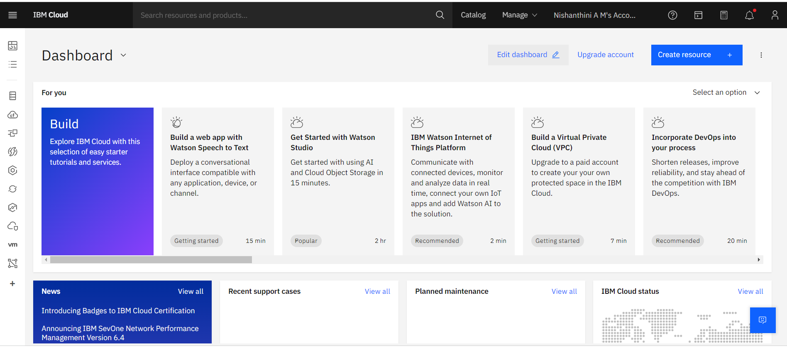

PRIYANKA S

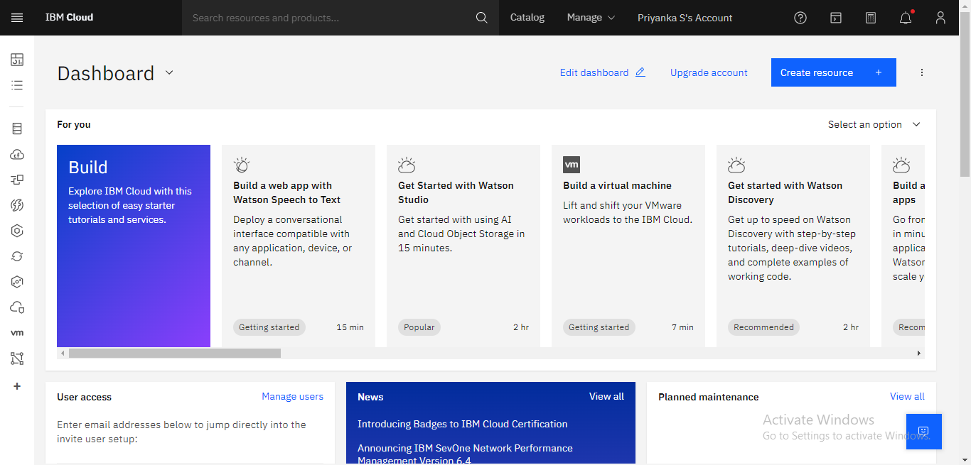

SANJANA S MENON

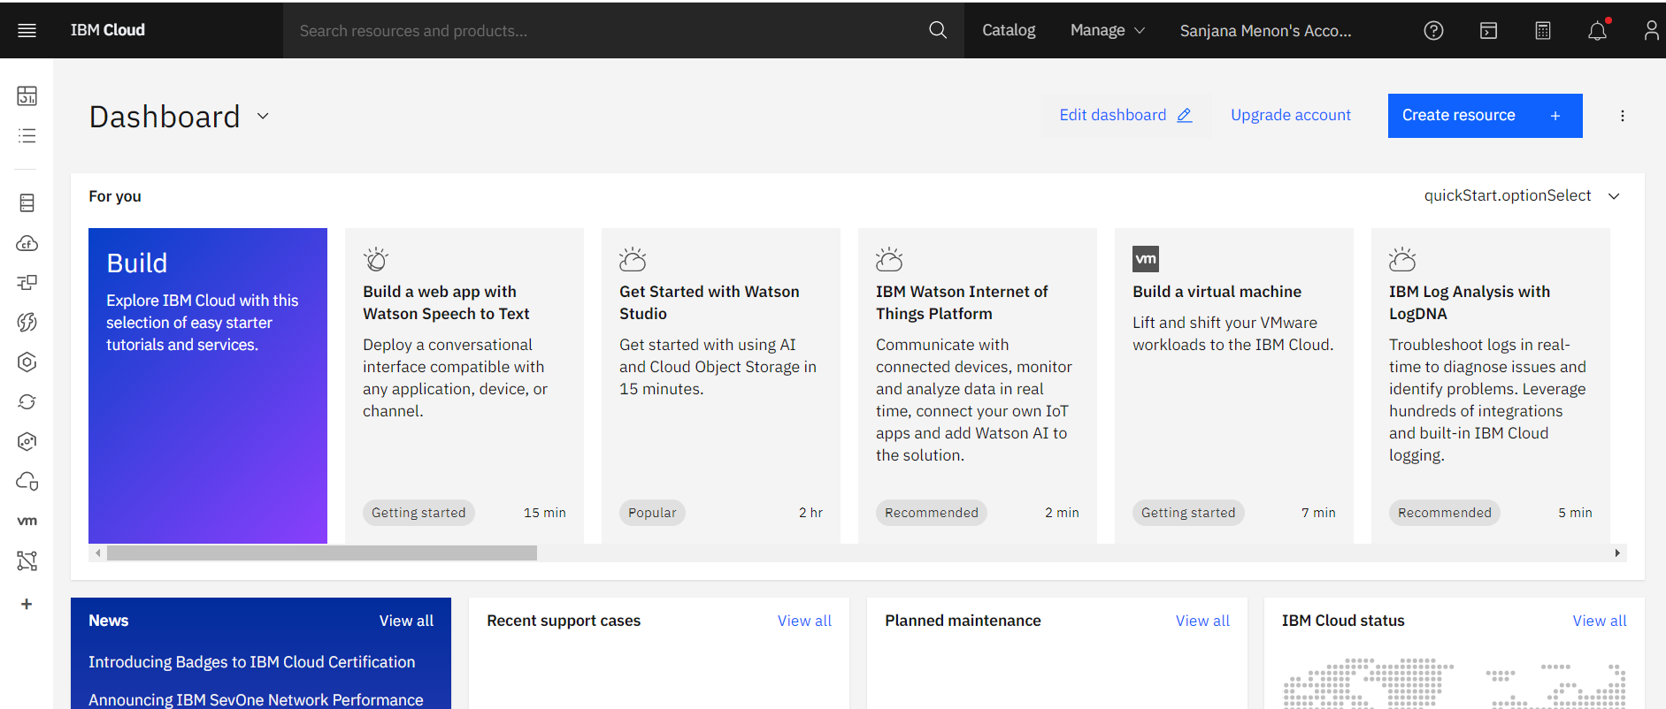

ZAMIN HAMID

